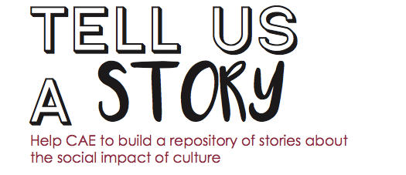

Title of the project:

Please describe your action/project

Tell us something more about your project/activity:
Content

Duration (from __/__/____/ to __/__/____/(or ongoing))
Location
Field/discipline

Tell us something about who did it: individual(s),
organization(s), formal, informal, their numbers, their role/skills, etc.
________________

Tell us something about the people who in your view received
the most significant impact: who were they? How many of them?
________________

Was the impact planned from the start?
________________

Tell us something about the context: recent history, social,
economic and cultural features
________________

Tell us what were your expected results and the actual ones
________________

Tell us something about the most relevant resource inputs of
your project/action: human, financial, organization, time
________________

Tell us how you have attained the main change: challenges,
innovation, obstacles, brilliant solutions, turning points, quantum
leaps, etc.
________________

Tell us the main area of impact of your project, i.e. a
permanent or long lasting change in attitudes, awareness, behavior, conditions, economic status, income, occupation, perception, practice, quality of life, self-esteem, skills, social relations, etc. and for whom.
________________

Which is the Big Idea behind your project/action?
________________

Please, send this document to stories@cultureactioneurope.org

If you have photos, videos, documents, reports, data,
presentations about the project and its impacts, send them to stories@cultureactioneurope.org (please provide summary English translation for material in other languages).

Please note that stories can be about old/discontinued projects.
We appreciate mid-long term impacts.
Our ideal projects should involve a certain degree of continuity and duration.
At the present stage, we prefer not to include occasional
and short events. We can consider short events if regularly staged (e.g.: a three-day festival or a special day that takes place every year in the same place).
We like success stories, but failure stories can also be very useful.
Significant differences between planned and unplanned impacts are also worth telling.

